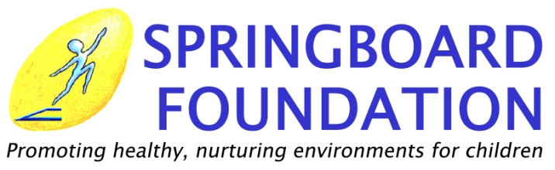

Grant Application Requirements

Thank you for sending a proposal to the Springboard Foundation. We are pleased to receive information about your plans to improve the life of poor children in the Philippines. The Springboard projects include the support of schools, daycare centers, improvement of homes and facilities for abandoned and abused children, medical facilities and supplies, small-scale livelihood programs and seminars to improve the life of the poor Filipino. Our policies and guidelines are as follows:

- Grant Recipient must complete the Grant Application Requirements of Springboard Foundation.
- Upon approval, the receiving organization may not deviate from the agreement outline in the project proposal.
- Any change must be applied for in writing.
- In case of closure of organization, misuse or diversion of funds, the grant will have to be returned in full.
- With the completed application form, please attach the following:

For Non-Government Organizations:
  - A copy of your SEC or DTI registration
  - A copy of DSWD registration (if applicable)
  - A copy of your DECS Certification (for all schools)
  - A copy of your Articles of Incorporation and By-Laws
  - A list of your Board of Directors, including their positions
  - An annual report of your accomplishments from the previous year
  - Copy of the last Bank Statement and Annual Financial Report of the previous year
  - Written estimate from two (2) different suppliers/buildings
  - Any brochures or pamphlets of your organization or project

For Government Agencies: □ Hospital □ School □ Institution
  - For hospitals and schools, a copy of your statistical report from the previous year
  - Written estimate from two (2) different suppliers/buildings
  - Any brochures or pamphlets of your organization or project

- Acknowledgment Letter if Grant Application has been approved.
- Barangay certification stated that this project really exists in the area if grant is approved.
- If the grant is given in partial payments, Springboard Foundation will require a Progress Report of Improvements before releasing the second fund.

Send your completed application form and all the supporting documents to:
SPRINGBOARD FOUNDATION
15 Melbourne St. Merville Park, Parañaque City 1704

For further inquiries, please call 821 5440.

Application Form

Name of Organization
Address
Telephone Number
Fax Number
Email

Person Responsible for the project
Position
Telephone Number

What is the mission of your organization?

How old is your organization?
SEC Registration No.
DSWD Registration No.
For government agencies, indicate your T.I.N. number

Please list any partnership with government or non-government offices.

Would you accept any used items? YES NO
If yes, please list any in particular

Would you like to have volunteers from Springboard Foundation? YES NO
If yes, please describe the type of help needed:

What are the other funding sources of your organization? (Check all that apply)
  - Individual Donations
  - Government Donations
  - Corporate Funding
  - Sale of Items or Services
  - Charitable Organization
  - International Agencies

Please list the names of organizations, corporations or international agencies that currently donate to your organization.

Project Proposal

Please include a project description that is a minimum of two and no more than four pages. Please include the following:

- Project Title
- Project Site (specify the distance and time from major cities and necessity of the project)
- Project Design
- Description of Project
- Amount of Money Requested
- Itemized Project Expenses
- Why this grant is needed?
- Who (and how many) will benefit from the proposal project and how will they benefit?

